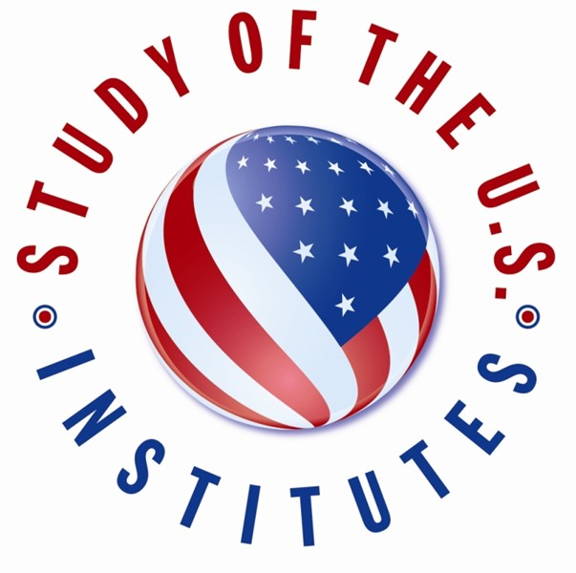

Candidate Contact Information:

Street Address: *

City: *

State/Province:

Postal Code:

Country: *

Phone Number: *

Email Address: *

Medical, Physical, Dietary, or other Personal Considerations:

This will not affect a candidate's selection, but it will enable the host institution to make any necessary accommodations

Please indicate if the candidate has a disability. *

- None

- Blind or Visual Impairments
- Deaf or Hearing Impairments
- Learning Disability
- Physical Disability
- Psychiatric Disability
- Systemic Disability
- Other

Please describe any pre-existing medical conditions, prescription medication, dietary restrictions, or personal considerations for the candidate.

Experience in the United States:

Has the applicant traveled to the United States before? *

- Yes
- No

If yes, please list any previous travel to the United States for the purposes of tourism/vacation, conferences, educational study, or previous ECA programs. Provide dates/duration, purpose of visit(s), and location(s). (Examples: July 4-14, 2019 - Tourism to Washington, D.C.; December 1-15, 2018 - Short Term Study Abroad to New York City, NY).

Has the applicant previously participated in or been accepted into another U.S. Department of State sponsored program? *

- Yes
- No

If yes, please provide the name of the program and the dates. *

Family Residing in the United States (if applicable):

Please include name, relationship to candidate, city, and state. (Example: Jane Doe, sister, Denver, CO).

SECTION B: CANDIDATE BACKGROUND

Year in School: *

- First-Year Student
- Completed First Year
- Completed Second Year
- Completed Third Year
- Completed Fourth Year
- Part-Time Student
- Postgraduate Student

Expected Date of Graduation: *

Will the candidate have one semester left in their studies after the completion of the SUSI program? *
- Yes
- No
- Other

Major/Field of Study: *

University: *

Country of University: *

Work History:
Please include employer, position, dates, and location.

Volunteer Experience:
Please include organization, dates, and location.

Memberships in Associations, Clubs, etc.:
Please include organization and dates.

Candidate Personal Statement: *
As part of the SUSI application process, candidates should submit a personal statement about their background and goals. In up to 500 words, the candidate should address the following questions and any other pertinent information:
- What about your background and interests makes you competitive for the SUSI program?
- What will you contribute to the program?
- How will your participation in the SUSI program affect your local community, region, or country?
- How will the SUSI exchange affect you personally or professionally?

Please input the candidate's personal statement below.

